**Collisions in One Dimension**

**Pre-lab questions**

1. What is the goal of this experiment? What physics and general science concepts does this activity demonstrate to the student?
2. When is the momentum of a system constant?
3. What is true for a completely elastic collision?

The goal of the experiment is to study whether linear momentum is conserved in 1-D collisions, and whether the total mechanical energy is conserved.

**Introduction:**

The momentum, **p**, of an object depends on its mass and velocity, **p** = *m***v**. The direction of the momentum vector is the same as the direction of the velocity. When more than one object is present, the total momentum of the system is the sum of the individual momentum vectors, $p_{tot}=\sum_{i}{p_{i}=}\sum_{i}{mv_{i}}$.

During a collision, the forces acting on a pair of colliding masses are a Newton’s 3rd law action-reaction force pair. Then the net force acting on the **system** of two masses is the vector sum of these action/reaction forces, which is a net force of zero. By Newton’s 2nd law, $F_{net}= ∆p/∆t$, the total momentum of the system is constant (conserved) when **F**net = 0 as $∆p=0$. This means that the total momentum just before the collision is equal to the total momentum just after the collision. If the momentum of one object decreases, the momentum of the other object increases by the same amount. This is true regardless of the type of collision, and even in cases where kinetic energy is not conserved.

The kinetic energy of an object also depends on its mass and speed but kinetic energy is a scalar, $K=\frac{1}{2}mv^{2}$. The total kinetic energy of a **system** of two masses, *m*1 and *m*2, is found by adding the kinetic energies of the individual objects. $K_{tot}=\frac{1}{2}m_{1}v_{1}^{2}+\frac{1}{2}m_{2}v_{2}^{2}$. When the interaction forces between the masses in a collision are conservative, the total kinetic energy is conserved and the collision is called completely **elastic**. When the masses collide and stick together, the collision is called completely **inelastic**. Most real collisions fall somewhere between these two cases.

Equipment:

Pasco Dynamics System, (2) acoustic motion sensor, 1 cart with plunger, 1 cart (preferably) without plunger, elastic bumper, balance scale.

Experiment

Elastic and inelastic collisions are performed with two dynamics carts of different masses. Magnetic bumpers are used in the elastic collision and Velcro® bumpers are used in the completely inelastic collision. Both the momentum and kinetic energy are examined before and after the collisions.

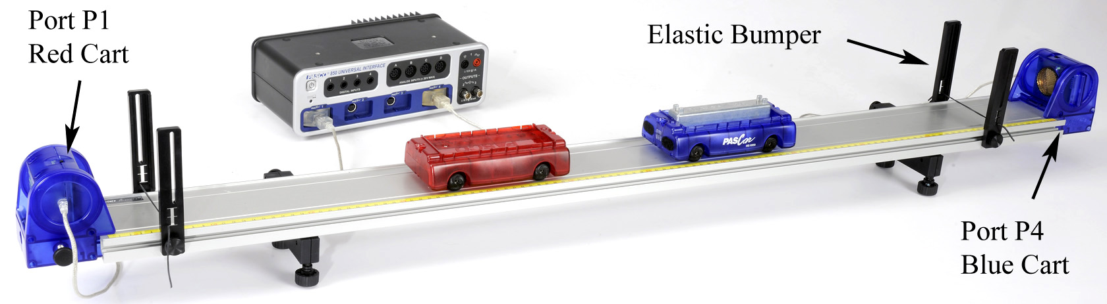

Figure 1: The velocity of each cart is measured using Motion Sensors

Setup

1. Install both elastic bumpers and adjustable feet as shown in Figure 1.
2. Use a balance scale to measure the mass of the red cart, and the mass of the blue cart with extra mass bar. [***Note: The carts are not colored red and blue. The “red” cart has the spring-loaded plunger.***]
3. Attach the Motion Sensors to the track. You must keep the orientation shown (see Fig. 1), with the Motion Sensor monitoring the red cart plugged into port P1 on the interface and the Motion Sensor monitoring the blue cart plugged into port P4.
4. Click the triangle at the bottom middle and change to Common. Set the Common sample rate to 50 Hz.
5. Create the following calculations:  
   (To create a calculation you need to click the calculator on left side of screen:  )

‎Vred‎ = [Velocity, Ch P1 (m/s)‎] units of m/s

‎Vblue‎ = -[Velocity, Ch P4 (m/s)‎] units of m/s

‎p‎ = Mred*Vred + Mblue*Vblue units of kg m/s

‎Mred ‎= 0.25 units of kg

‎Mblue‎ = 0.50 units of kg

‎K = 0.5*Mred*(Vred)² + 0.5*Mblue*(Vblue)² units of J

Substitute your values for the masses of the carts.

1. Create a graph of Vred vs. Time. Then add Vblue to the vertical axis using Add Similar Measurement.
2. Level the track using the leveling screws on the track feet. When you place a cart at rest on the track, give it a little push in each direction. It should not accelerate in either direction.
3. 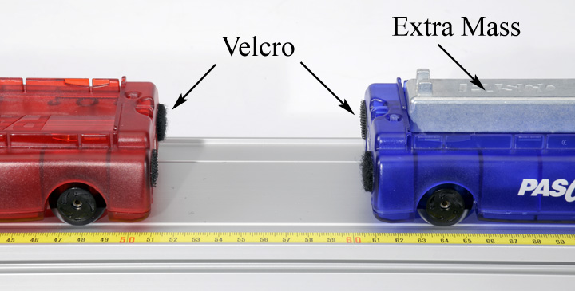Orient the carts so that the Velcro® ends are facing each other, as shown in Figure 2.
4. The program is set up so that the velocities of both carts are positive to the right, when the carts are moving away from the Motion Sensor plugged into port P1. Click on Record and give the carts a push to the right. Make sure that you are getting good, clean data, and that the velocities are both positive. Open the Calculator Window to see calculations #1 and #2 where these signs are set.

Figure 2: Setup for Completely Inelastic Collisions

1. Click on Recording Conditions at the bottom: . Create a Stop Condition that is Measurement Based on the Position for the Blue Cart when it Falls Below 0.600 m.

Inelastic Procedure

1. Position the blue cart (with extra mass bar) about 90 cm from its Motion Sensor and the red cart about 90 cm from its Motion Sensor.
2. Click on Record and push the red cart towards the blue. The automatic stop condition should halt data collection when the blue cart is closer than 60 cm from the sensor.
3. Get one good run with smooth clean data before and after the collision. Open the Data Summary and rename this run "Inelastic".
4. Using the Coordinates tool (), measure the velocity of the red cart just before and after the collision.
5. Calculate the total momentum before and after the collision. What do you conclude? Was momentum conserved?

Elastic Procedure

1. Reverse the two carts so that the ends with the magnets are facing each other, but keep the red cart near the Motion Sensor connected to Channel P1.
2. Position the carts on the track as before. Click on Record and push the red cart towards the blue. Get one good run of data and name this run "elastic".
3. Using the Multi-Coordinates tool, measure the velocity of the red cart just before and after the collision. Hint: Don't ignore the sign of the velocity!
4. Measure the velocity of the blue cart just after the collision.
5. Calculate the total momentum before and after the collision. What do you conclude? Was momentum conserved?
6. Was it harder to determine when to measure for this elastic collision? Why are the curves more rounded at the collision point?

Momentum

1. Add a plot area () to the Velocity vs. Time graph. Put p (momentum) on the vertical axis of the second plot area.
2. Open the Calculator Window. Look at calculation #3 which automatically calculates the total momentum of the two carts for the entire data run. You can replace the approximate masses of the carts (calculations #4 and #5) with your actual values.
3. Use the run selector to display the data for the "inelastic" collision.
4. Examine the momentum graph to see what happens before, during and after the collision. Does it look like momentum is conserved?
5. Repeat for the "elastic" collision.

Kinetic Energy

1. On the second plot area, click on “p” on the vertical axis and select “K”.
2. Open the Calculator Window. Look at calculation #6 which automatically calculates the total kinetic energy of the two carts for the entire data run.
3. Use the run selector to display the data for the "inelastic" collision.
4. Examine the kinetic energy graph to see what happens before, during and after the collision. Does it look like energy is conserved? Where did the energy go?
5. Pick a point before and after the collision and calculate the kinetic energy for yourself. Does your calculated value agree with the graph?
6. Select the "elastic" collision. Explain this curve. What happens to the kinetic energy during the collision? Why does it decrease during the collision and then come back? Where did it go?

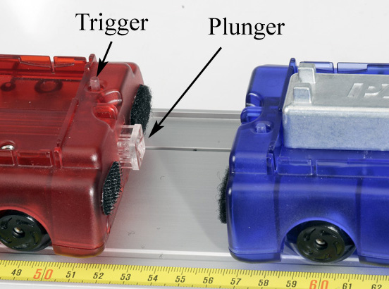Explosion

Figure 3: Cart explosion

1. Position the two carts so that they have the Velcro ends facing each other. Depress the plunger on the red cart to position #3 as shown in Figure 3.
2. Place the two carts in contact with each other in the center of the track.
3. Start recording and tap the trigger release (see Fig. 3) to launch the carts.
4. Get one good run of data and name this run "explosion".

Momentum and Kinetic Energy for the Explosion

Answer the following questions before examining the graph of your explosion data!

1. What was the total momentum of both carts before the explosion?
2. What was the total momentum of both carts after the explosion?
3. What was the total kinetic energy of both carts before the explosion?
4. After the explosion, is the total kinetic energy of both carts the same as before?
5. On the graph, select “p” on the vertical axis of the first plot area and “K” on the vertical axis of the second plot area.
6. Now use the Data selector to display graphs of momentum and energy for the explosion. Did you answer the above questions correctly?